The University of Chicago Computer Science Department

PRESENTS:
“Sampling, counting, and local central limit theorems”

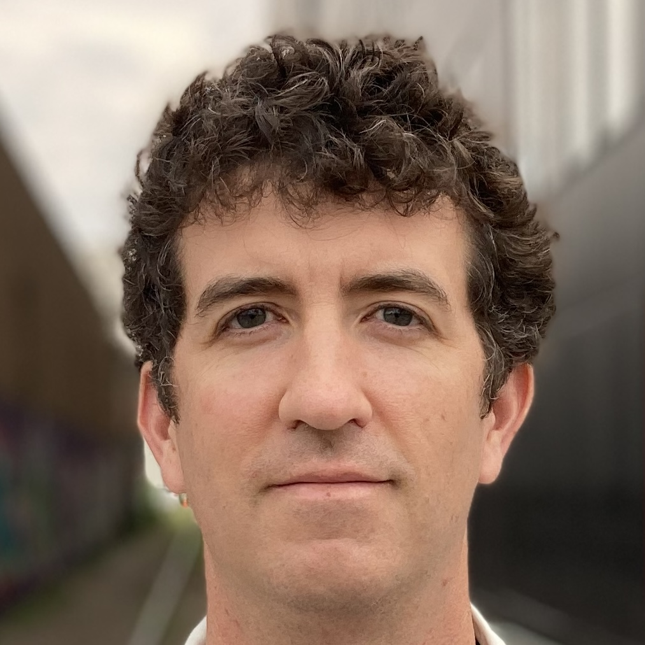

Will Perkins
Associate Professor, University of Illinois at Chicago

Abstract: I will describe how local central limit theorems (and Fourier-analytic proofs of local central limit theorems) can be used to design fast sampling algorithms and deterministic approximate counting algorithms for the number of independent sets and matchings of a given size in bounded degree graphs. Joint work with Vishesh Jain, Ashwin Sah, and Mehtaab Sawhney.

Bio: Will Perkins is an associate professor in the department of Mathematics, Statistics, and Computer Science at the University of Illinois at Chicago. Prior to this he was faculty at the University of Birmingham in the UK and a postdoc at Georgia Tech. He received his PhD in 2011 from the Courant Institute at New York University under the supervision of Joel Spencer. His research interests are in algorithms, probability, and combinatorics. One of his recent research directions is in developing methods in combinatorics and algorithms based on tools and intuition from statistical physics.

Tuesday, April 12, 2022
Kent 107, 3:30 pm
Host: Alexander Razborov

People in need of assistance should call 773-702-6614 in advance.
For additional information on future CS talks please visit: http://cs.uchicago.edu/calendar

