The University of Chicago

Department of Computer Science & Mathematics

Combinatorics & Theory Seminar

PRESENTS:

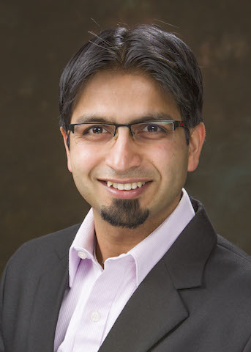

Sushant Sachdeva
University of Toronto
http://www.cs.toronto.edu/~sachdeva/

Title: “Iterative Refinement for p-norms”

Abstract: In the current optimization literature, for several convex programs, it is significantly faster to obtain O(1)-approximate solutions as compared to high accuracy (1+1/poly(n))-approximate solutions. This gap is reflected in the differences between interior point methods vs. (accelerated) gradient descent for regression problems, and between exact vs. approximate undirected max-flow. One exception has been L2-regression, where an algorithm for computing an approximate solution can be converted into a high-accuracy solution via iterative refinement. In this talk, we will present generalizations of iterative refinement to p-norms. This leads to algorithms that produce high accuracy solutions by crudely solving only a polylogarithmic number of residual problems. I will also discuss several results that build on this new approach to high-accuracy algorithms, including p-norm regression using m^{1/3} linear system solves, and p-norm flow in undirected unweighted graphs in almost-linear time.

This talk will be based on joint works with Deeksha Adil, Richard Peng, Rasmus Kyng, and Di Wang.

Host: Prof. Madhur Tulsiani

Tuesday, February 12, 2019
Ry. 251 @ 3:30 pm
(Refreshments will be served prior to the talk in Ry. 255 @ 3:15pm)

