The University of Chicago

Department of Computer Science & Mathematics

Combinatorics & Theory Seminar

PRESENTS:

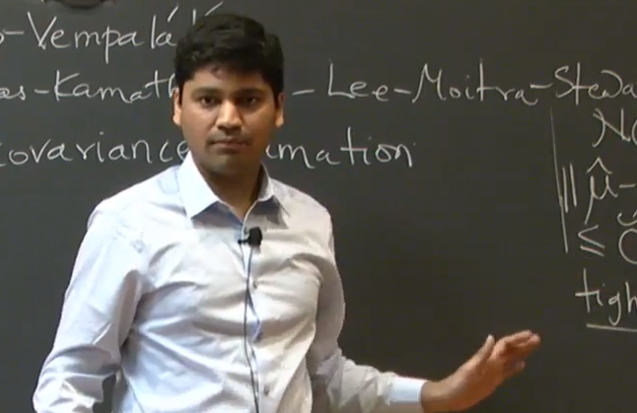

Pravesh Kothari
Princeton University & IAS

Title: (Quasi)-Efficiently Learning Mixtures of Gaussians at the Statistically Optimal Separation

Abstract: Recovering a hidden signal or structure in the presence of random noise is a recurring theme in fundamental problems arising in computational complexity, cryptography, machine learning, and statistics. In the recent years, a Sum-of-Squares method, a hierarchy of generic semi-definite programming relaxations, has yielded a systematic approach for such "parameter estimation" problems.

In this talk, I'll illustrate the SoS method for parameter estimation by means of a recent application of to learning mixture of gaussians with information theoretically optimal cluster-separation in quasi-polynomial time. No sub-exponential time algorithm was previously known in this regime.

Based on joint works with Jacob Steinhardt and David Steurer.

Host: Prof. Aaron Potechin

Tuesday, December 4, 2018
Ry. 251 @ 3:30 pm
(Refreshments will be served prior to the talk in Ry. 255 @ 3:15pm

