The University of Chicago

Department of Computer Science & Mathematics

Combinatorics & Theoretical Seminar

PRESENTS:

Rocco Servedio
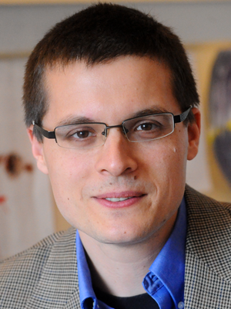

Columbia University

Title: Learning Sums of Independent Commonly Supported Integer Random Variables

Abstract:
For S a finite set of natural numbers, an "S-supported SICSIRV" is a random variable which is the sum of N independent random variables each of which is supported on S. So, for example, if S = {0,1}, then an S-supported SICSIRV is a sum of N independent but not necessarily identically distributed Bernoulli random variables (a.k.a. a Poisson Binomial random variable). Daskalakis et. al. (STOC'12, FOCS'13) have shown that for S={0,1,...,k-1}, there is an algorithm for learning an unknown S-SICSIRV using poly(k,1/\epsilon) draws from the distribution and running in poly(k,1/\epsilon) time, independent of N.
In this work we investigate the problem of learning an unknown S-SICSIRV where S={a_1,...,a_k} may be any finite set. We show that * when k=3, it is possible to learn any S-SICSIRV with poly(1/\epsilon) samples, independent of the values a_1,a_2,a_3;

Tuesday, May 2, 2017
3:00 pm
Ryerson 251
Host: Prof. Alexander Razborov
Refreshments will be served prior to the talk at 2:30 in Ry. 255

